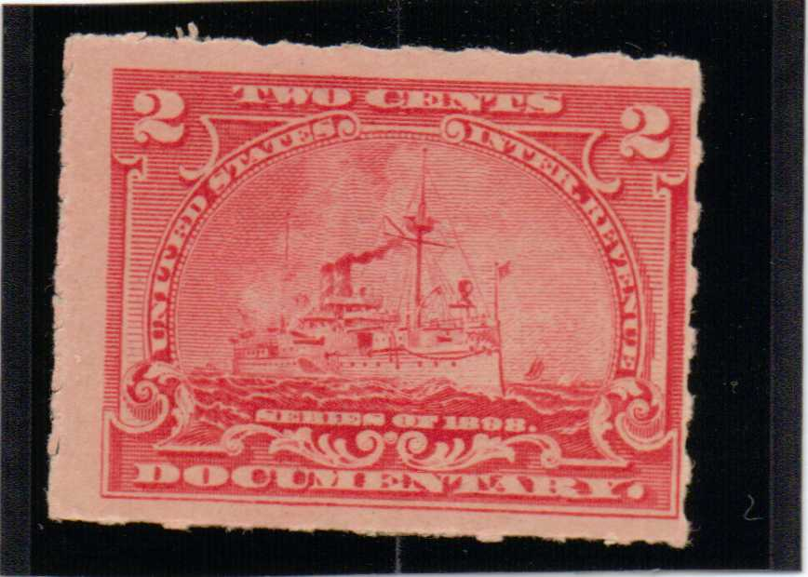**Examples of Hyphen Hole Perforation and Roulette Perforation**

Rouletted

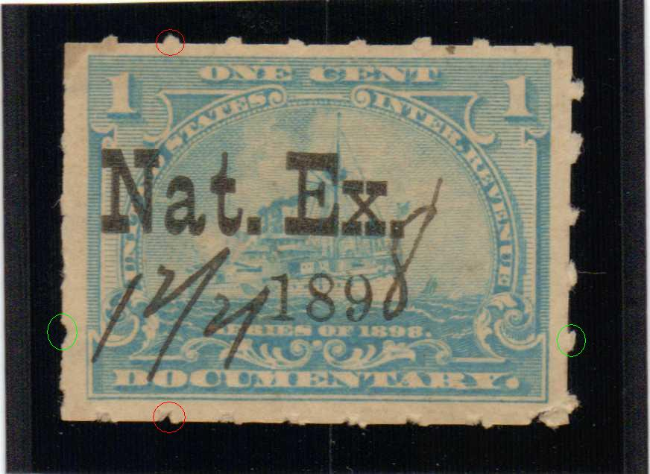

Roulett

Hyphen Hole Perforation

Yes, looking at the top edge of the top stamp, it "appears" to be like hyphen hole. But if you examine the bottom edge of that stamp, you will understand what has happened. Compare the red circles. The bits of paper you see sticking out at the top edge are not because hyphens have been punched out in between, but because part of the stamp that was originally above it have been torn out. Compare the green circles and you will see the same thing in the left/right sides.  
  
I agree, sometimes it can be very difficult to tell, especially if the perforation is weak, as in the bottom stamp. However, another way to tell is the gauge -- roulette 5.5 while the hyphen hole is perf 7.

By the way, for this stamp, the quick way to distinguish is by simply counting the number of slits/holes there are on either the left or right side within the vertical length of the stamp design.

Top one is rouletted, bottom one is hyphen hole perforated.